Zachary Klebanoff

David Roster

ECE 154A

Lab 4: MIPS Single-Cycle Processor

**Breakdown:**

My partner and I started the lab on Thursday (11/8) and worked on it until the final minutes before it was due (11/14). We estimated spent a total of 50+ hours with about half trying to debug the code. We had issues with coding in Verilog and some of these mistakes costed us half a day in some cases.

**Table 1:**



**Simulation Waveforms:**

*Part 1:*

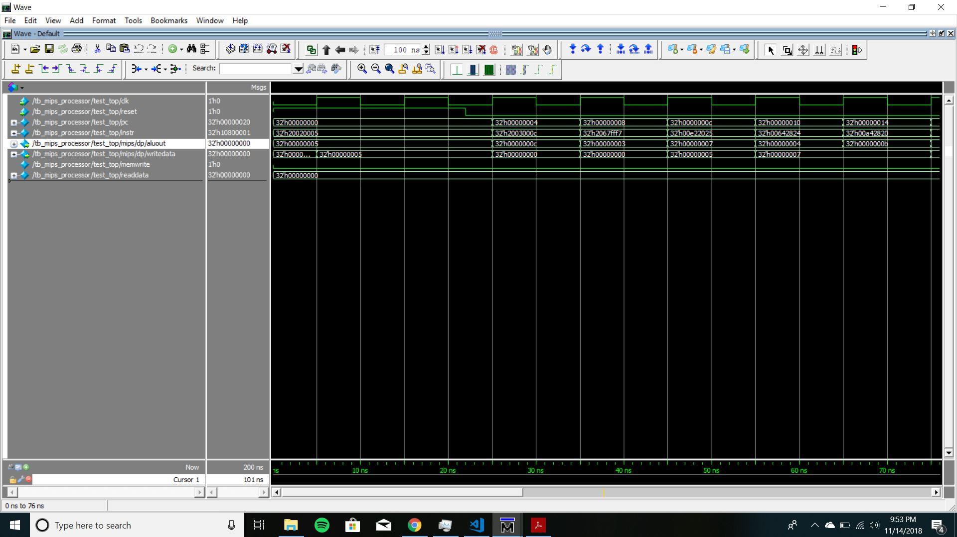

*Part 2:*

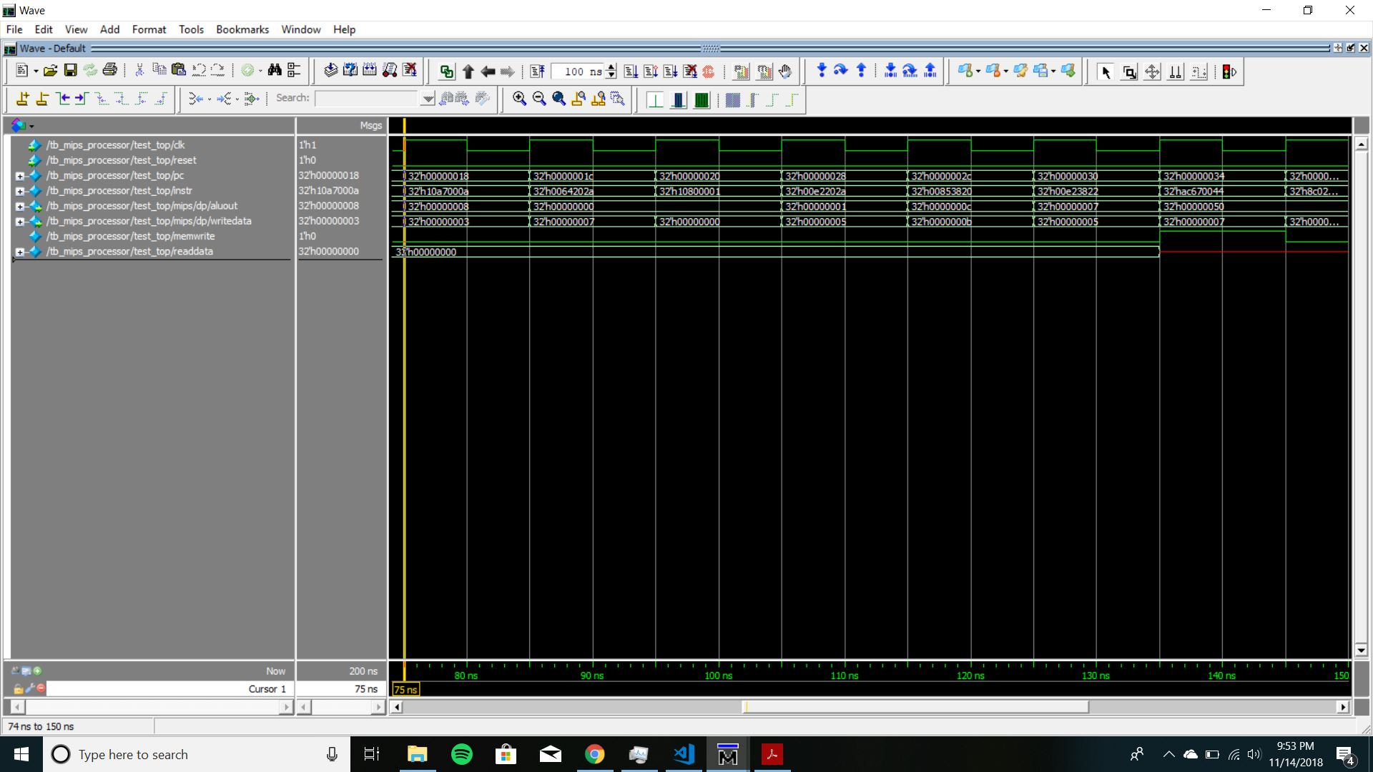

*Part 3:*

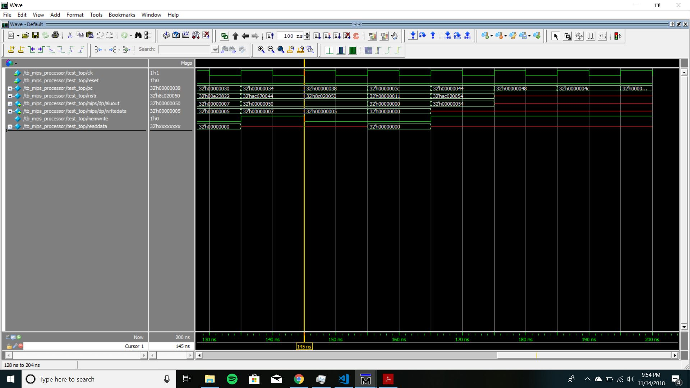

**Datapath Schematic:**

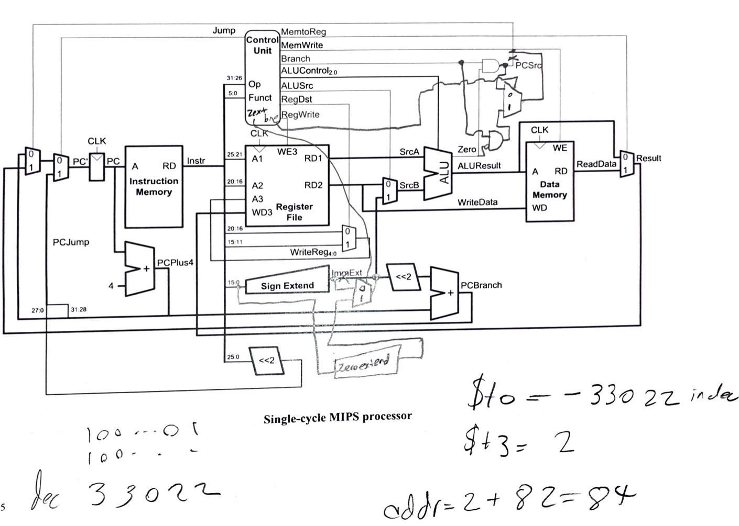

**Mips Verilog code with BNE and ORI:**

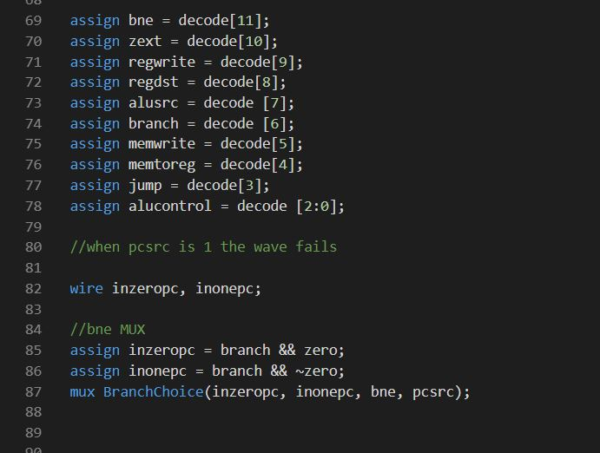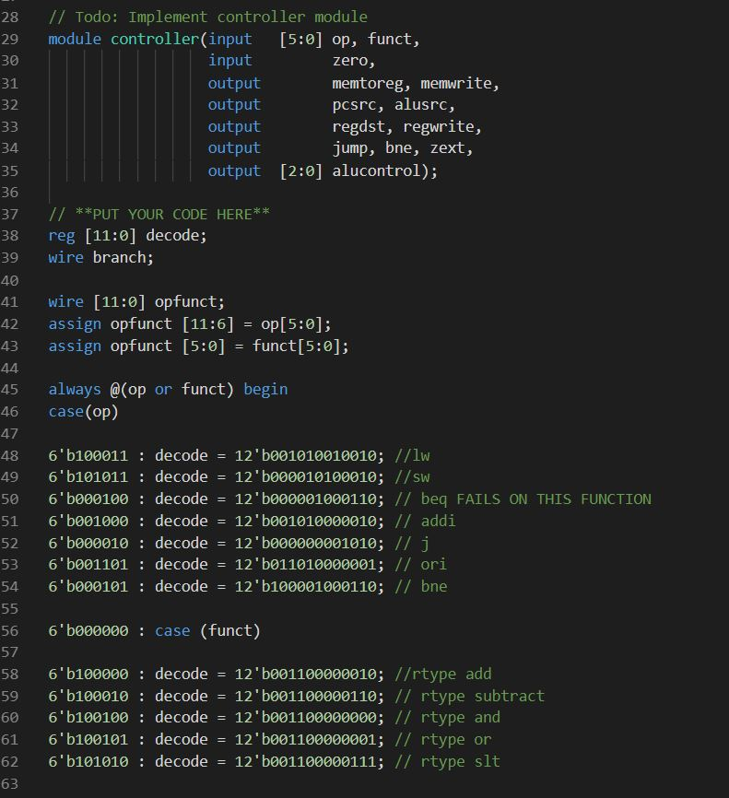

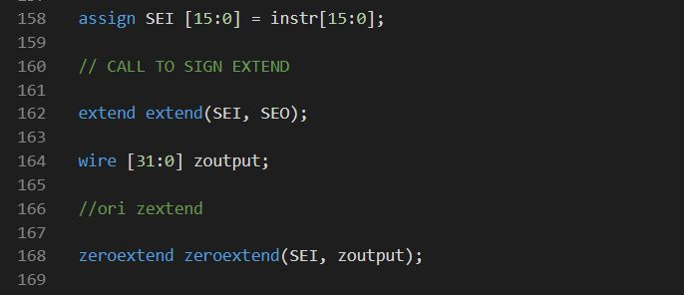

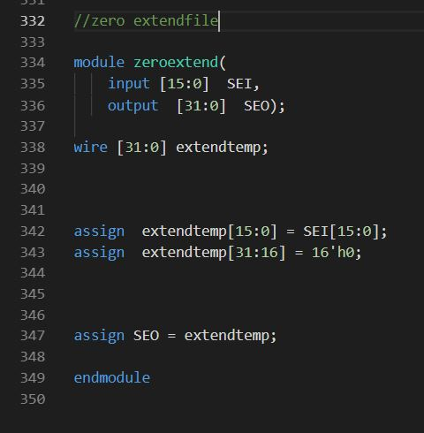

**Tables 2 and 3:**



**Memfile2.dat:**

34088000

20098000

350a8001

11090005

0128582a

15600001

08000009

01485022

350800ff

016a5820

01484022

ad680052

**Modified Processor with BNE and ORI Waveforms:**

The address is 84 and the value is -33022 .

